

User Manual

Index

User Manual - 1 -
Operating Environment - 3 -
User Login - 4 -
Projects - 5 -
Builds - 15 -
Groups - 16 -
Administrator - 16 -

Operating Environment
if you want to run webhob successfully, you need to install the following software in Ubuntu.
- Software
  - Django(https://www.djangoproject.com/download/)
$ tar xzvf Django-1.4.1.tar.gz
$ cd Django-1.4.1
$ sudo python setup.py install
  - MySQL
$ sudo apt-get install python-setuptools
$ sudo apt-get install mysql-server
$ sudo apt-get install python-mysqldb

- Configure Django Operating Environment
the above software installation is complete, then go on to create webhob database.
$ mysql –uroot –proot;
mysql> create database db_webhob;
mysql> quit;

enter django project folder, execute the following command to start django service program.
$ cd webHob;
webHob$ python manage.py syncdb #create webhob database
webHob$ python manage.py runserver #start django service

- Visit webhob home page
once django server started successfully, in the browser, you can input “http://localhost:8000”, if everything is ok, then you can visit webhob home page(picture 1)
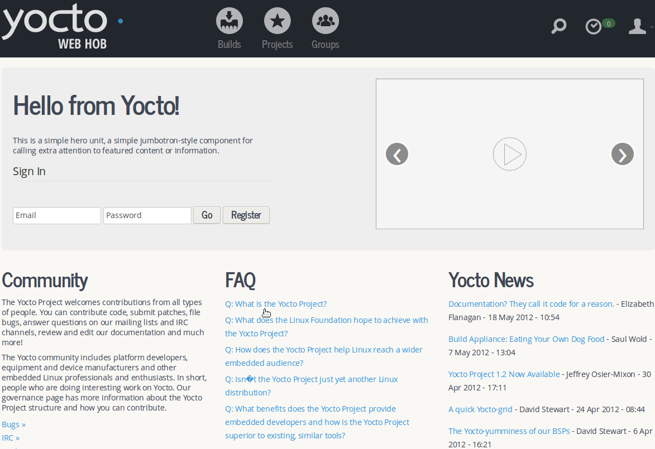
picture 1

User Login
- register
before user login in webhob, he need to register an account first , prohibit to add the same user to webhob.(picture 2)
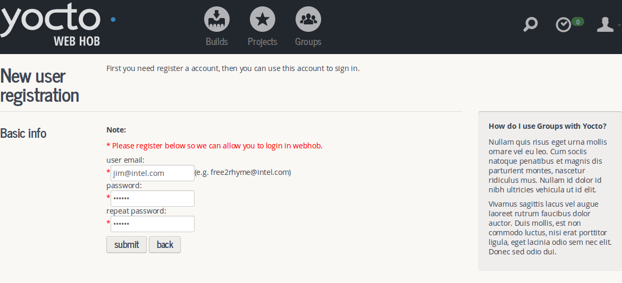
picture 2
- user login
if username and password are correct, user will enter webhob system successfully.(picture 3).
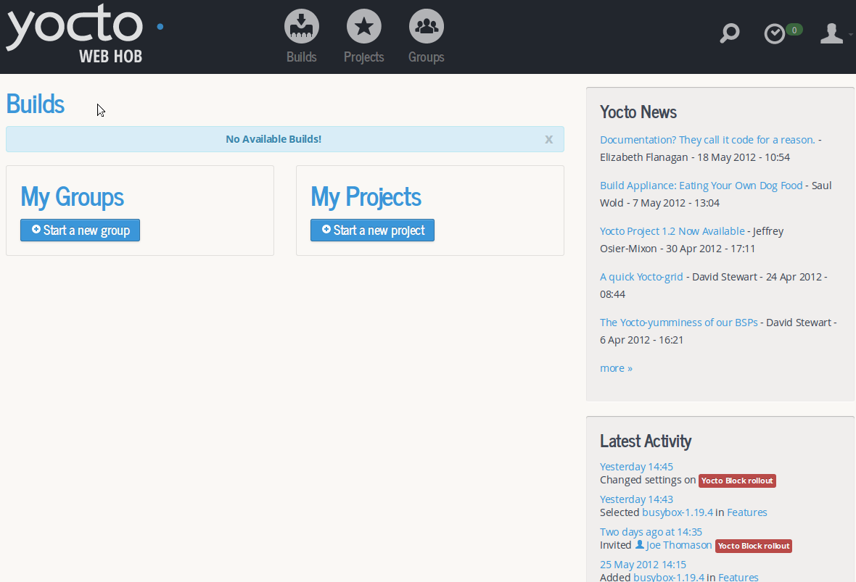
picture 3

Projects
- create project
in webhob, user need to create one project first before he starts to build, not allow to add the project which has been added. click “create project” button, management will assign one idle bitbake to user, create project and get advance settings from specified bitbake, user can add many projects by himself, else user can belong to different project team, in the same project, members can share project settings and their builds.(*note: to bind user to one bitbake, when user builds image is ok or user’s guid is invalid , the bitbake will be released automatically).(picture 4,5)
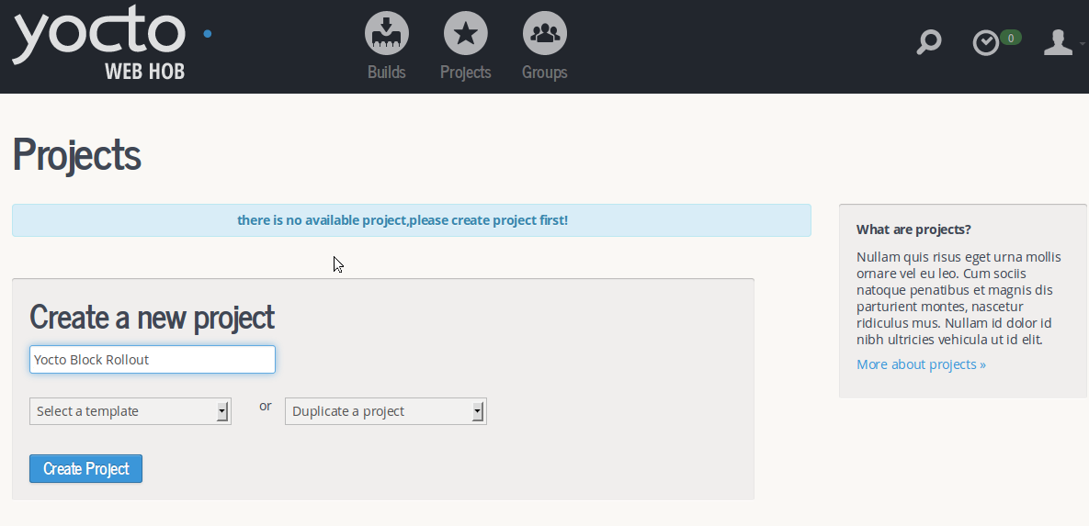
project 4
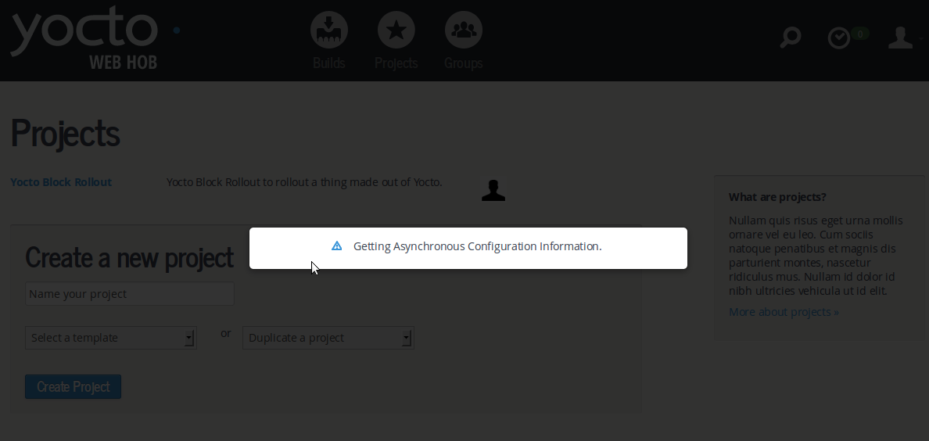
picture 5
- project detail information
in projects page, click ”Yocto Block Rollout”, go to project detail page.( picture 6)
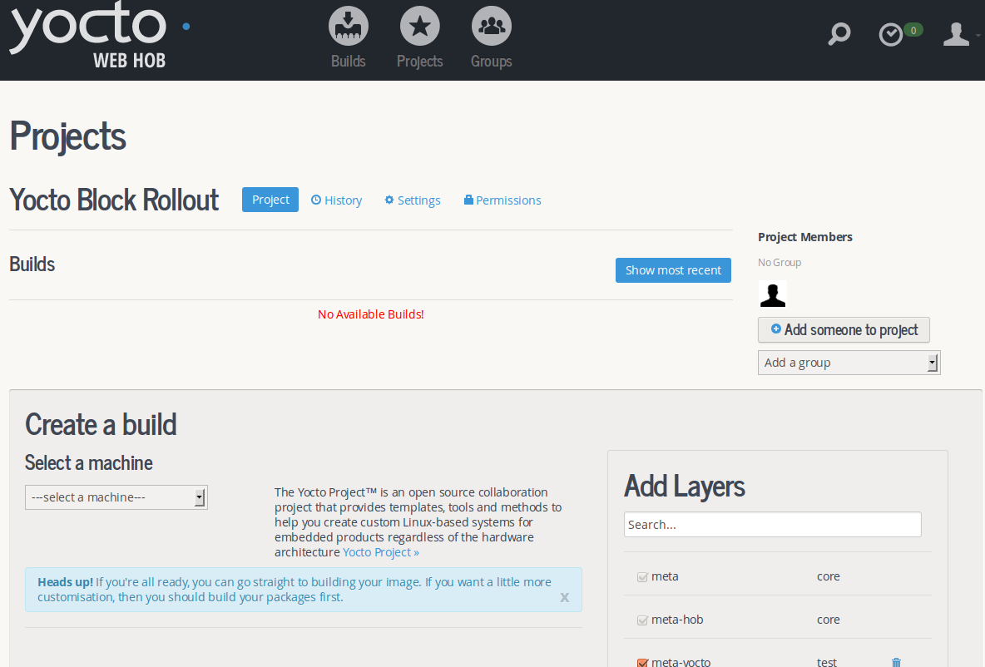
picture 6
- add member to project
prohibit to add person who has not registered in webhob to project, anonymous user who does not belong to any group can be allowed to add to project.(picture 7)
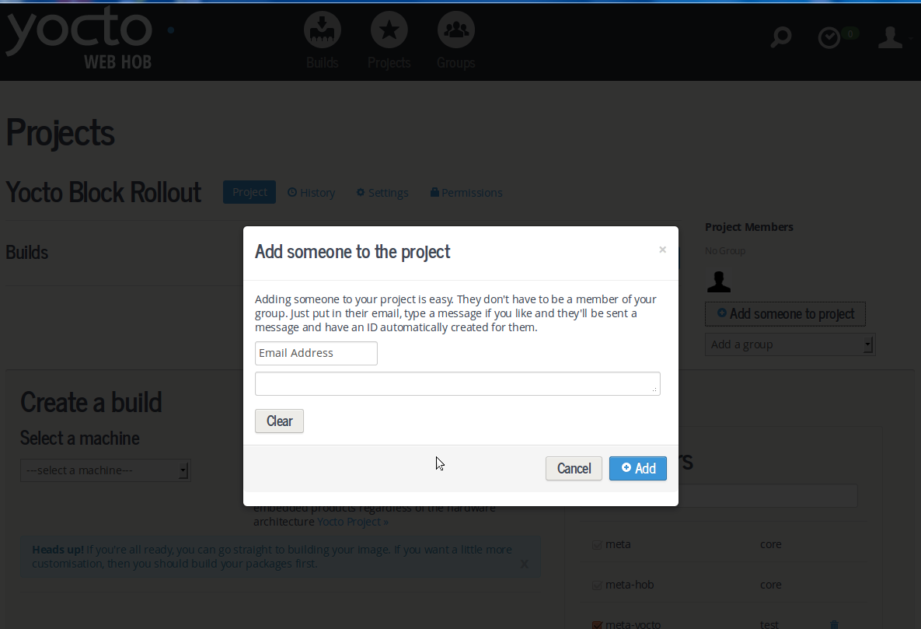
picture 7
- add group to project
webhob only allows user to add group that created by themselves to project.( picture 8,9)
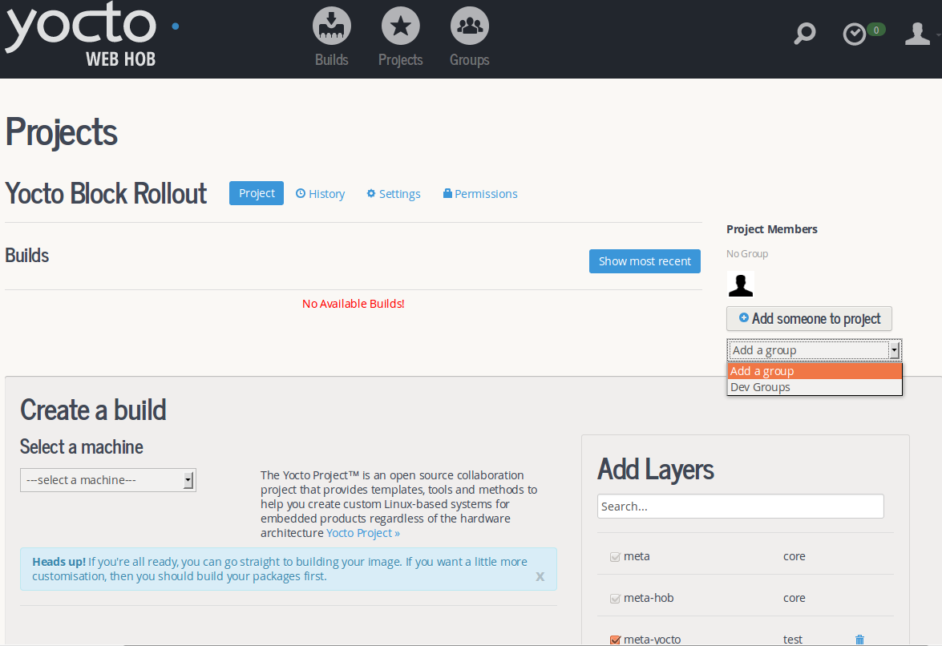
picture 8
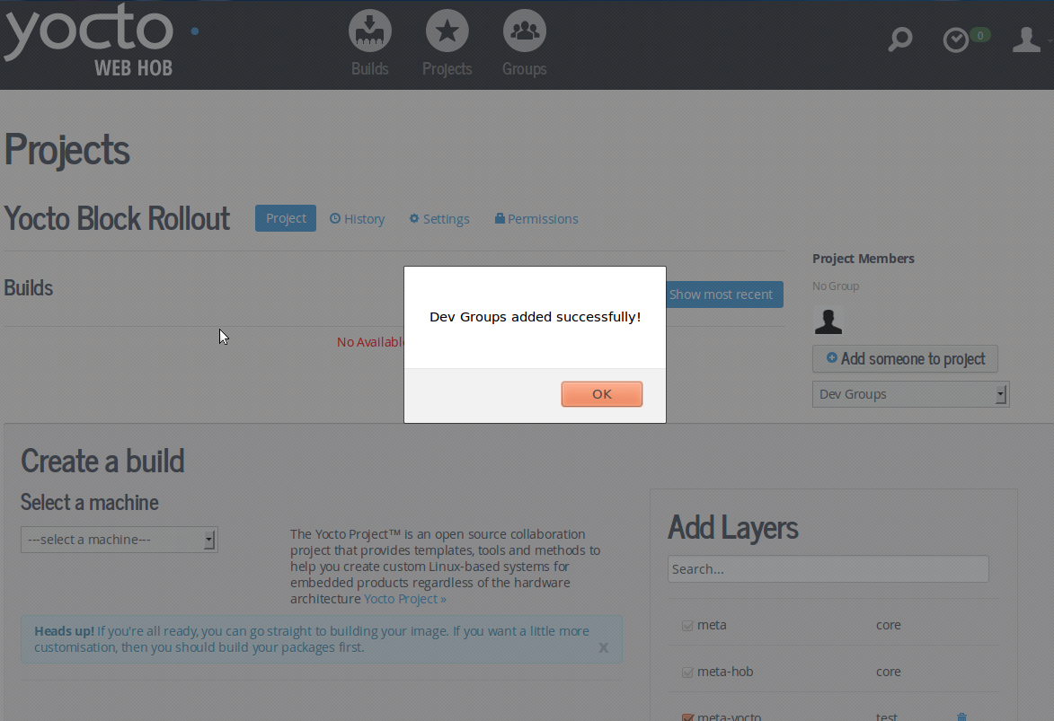
picture 9
- project history
if user want to see project history records, he can view by clicking “history”.( picture 10)
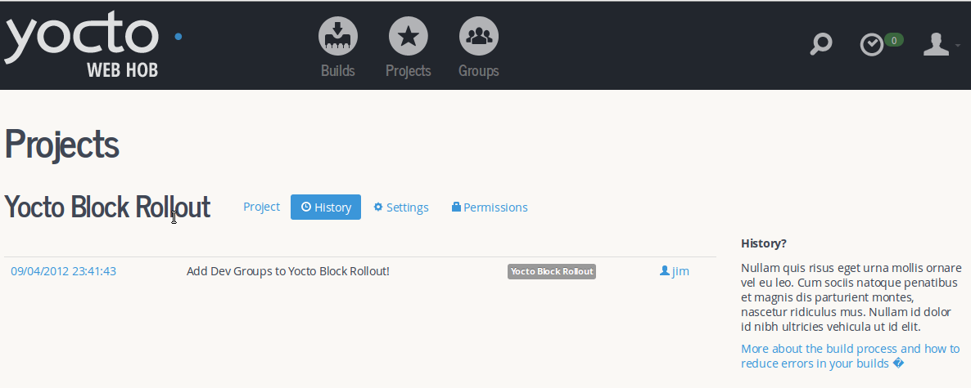
picture 10
- project advance settings
in the same projct, all members share project advance settings, once person want to modify advance settings , then he will affect entire project setttins config. click “Save settings as template” or “Archive project” will update project advance settings. (picture 11)
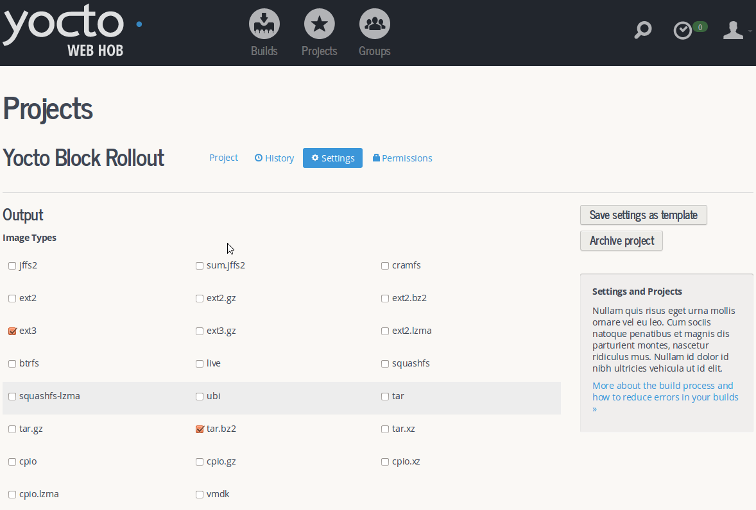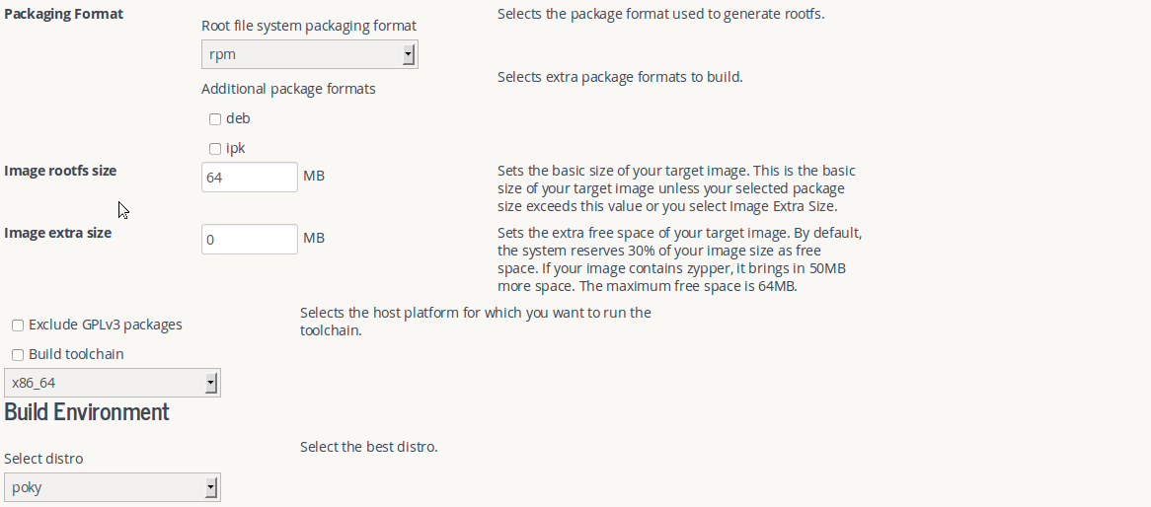
picture 11
- project groups
Click “permissions”, to view project’s groups, user can add any member who has registered in webhob to corresponding group, also to assign group permission to member.( picture 12)
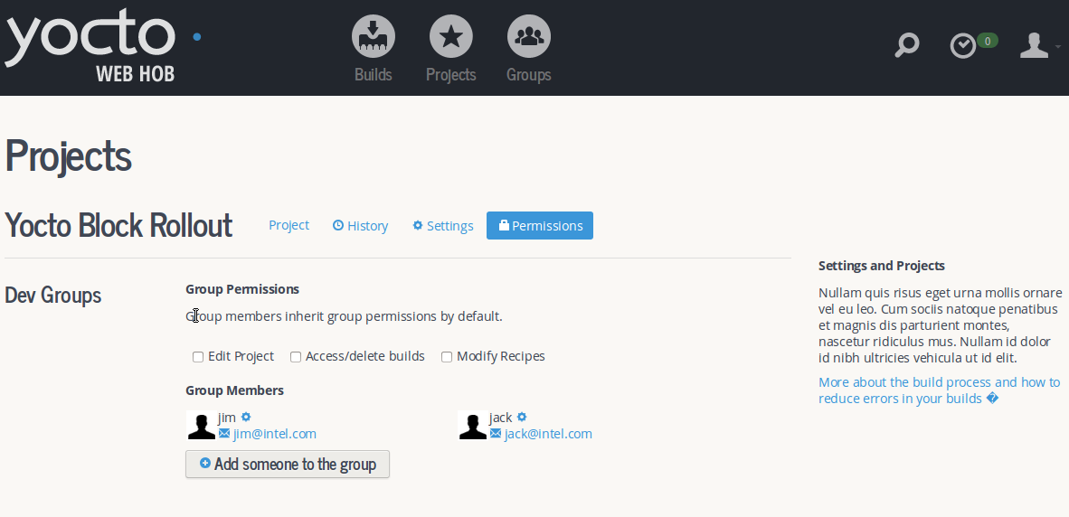
picture 12
- edit layer list
Click , then start to delete layer and reload advance settings, machine list values will be changed automatically. webhob allows user to upload their layer files to bitbake.
- parse recipe
when user select one machine, then start to parse recipe, for example, if one person selected “qemux86” in machine list, bitbake get user’s request and start to parse recipe.( picture 13, 14)
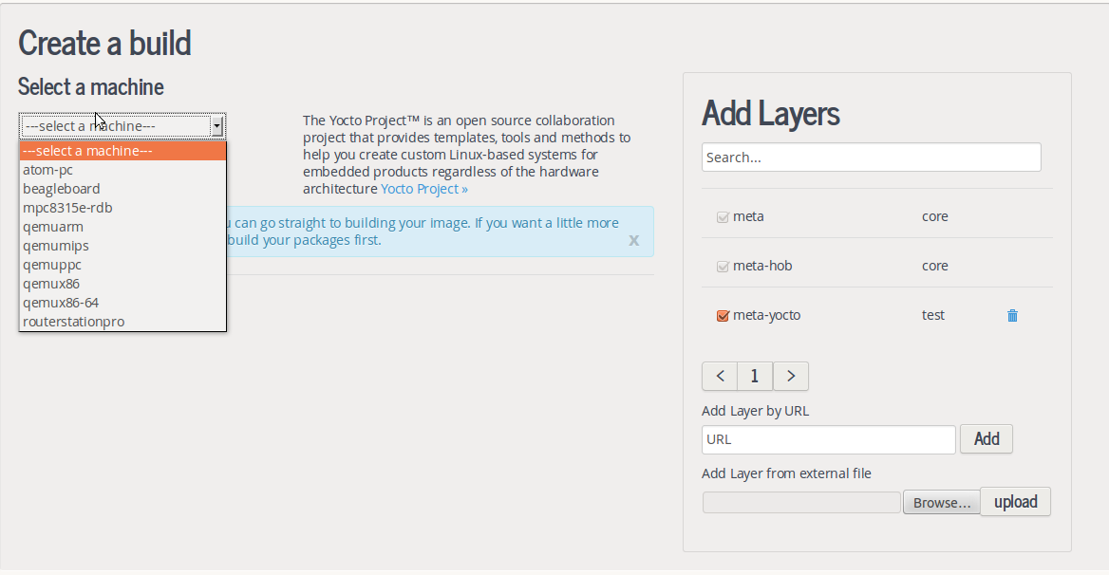
picture 13
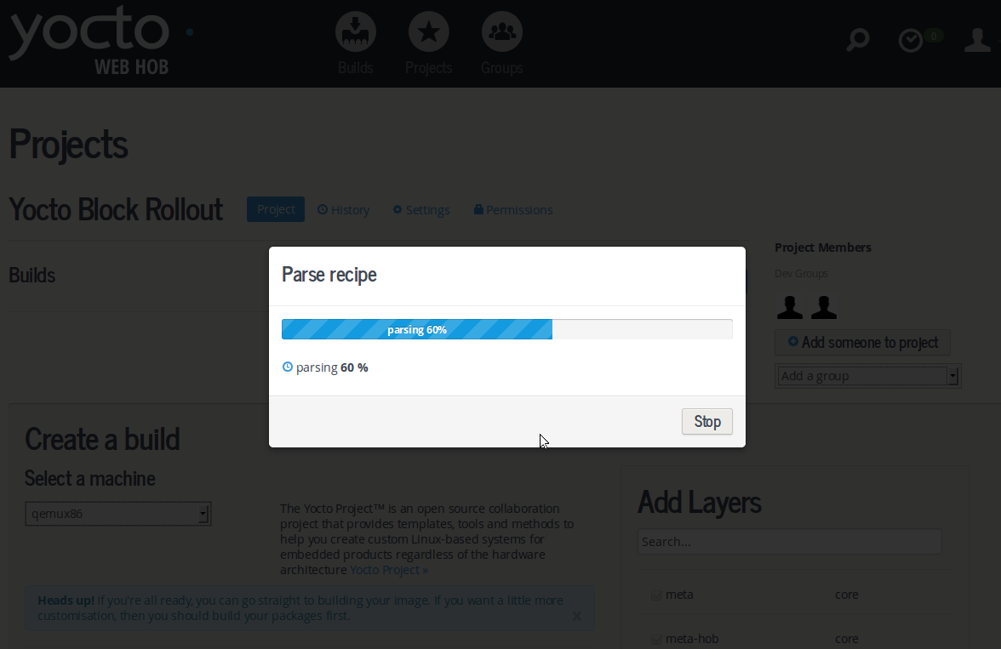
picture 14
when parse recipe finished, display base image list.( picture 15)
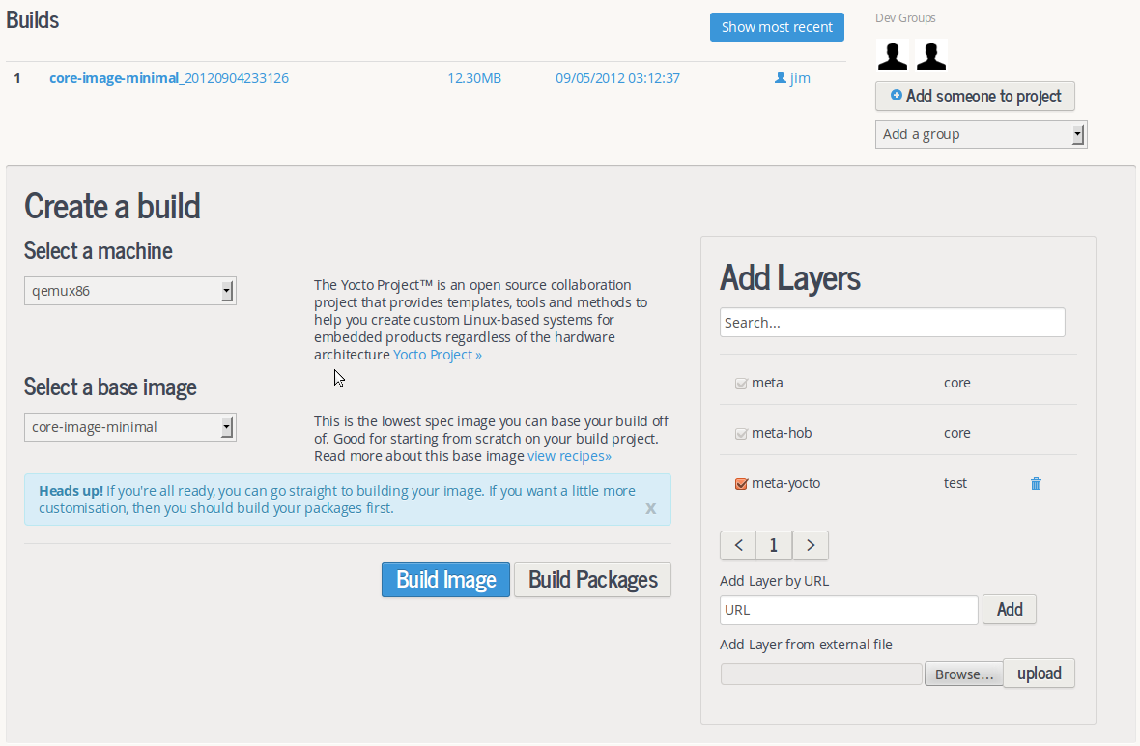
picture 15
selected “core-image-minimal” and click , you can see the dependent packages are automatically checked(picture 16,17).
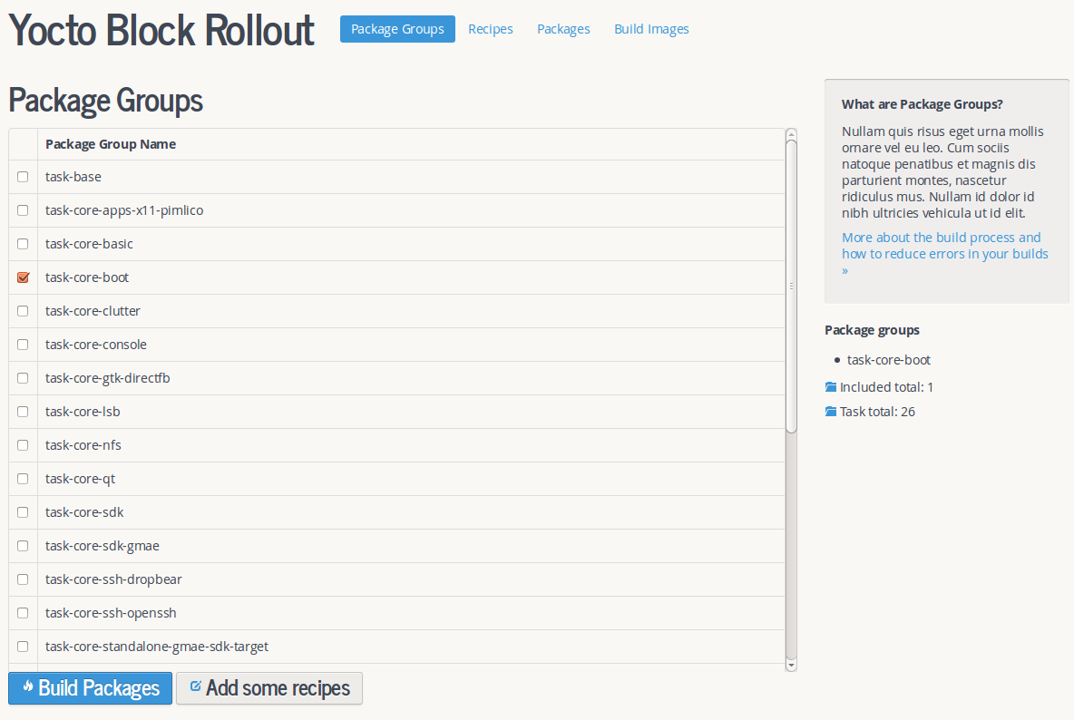
picture 16
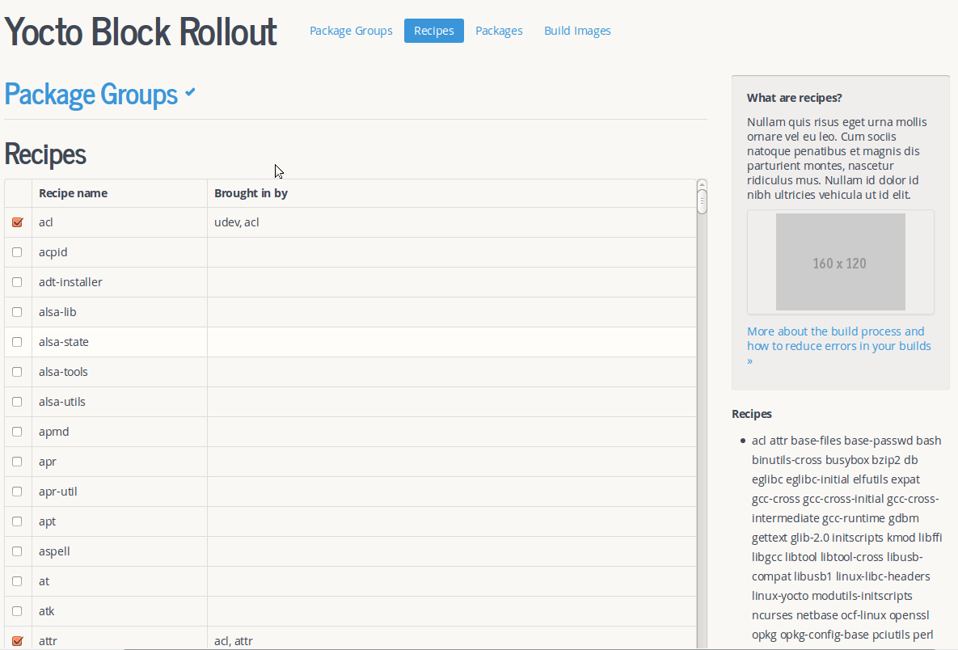
picture 17
- build package
click  or  or , then start to build package.(*note: when user builded image successfully, the bitbake that user connected will be released automatically, if user not change machine value or baseImage value, to click “Build Packages” or “packages” once again, only to display package tree last builded)( picture 18, 19, 20)
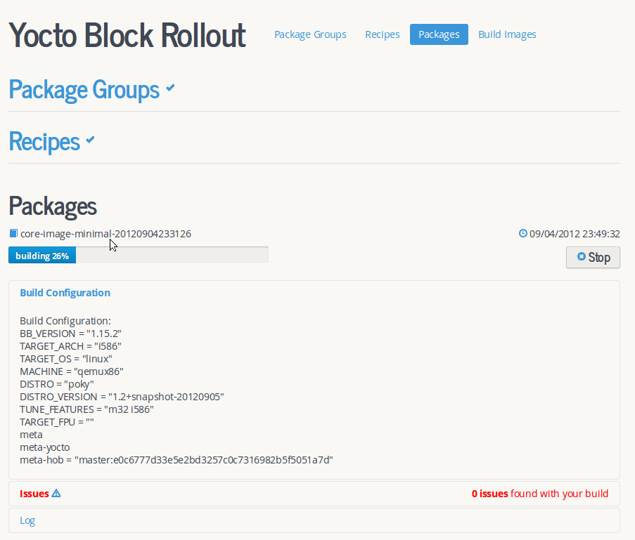
picture 18
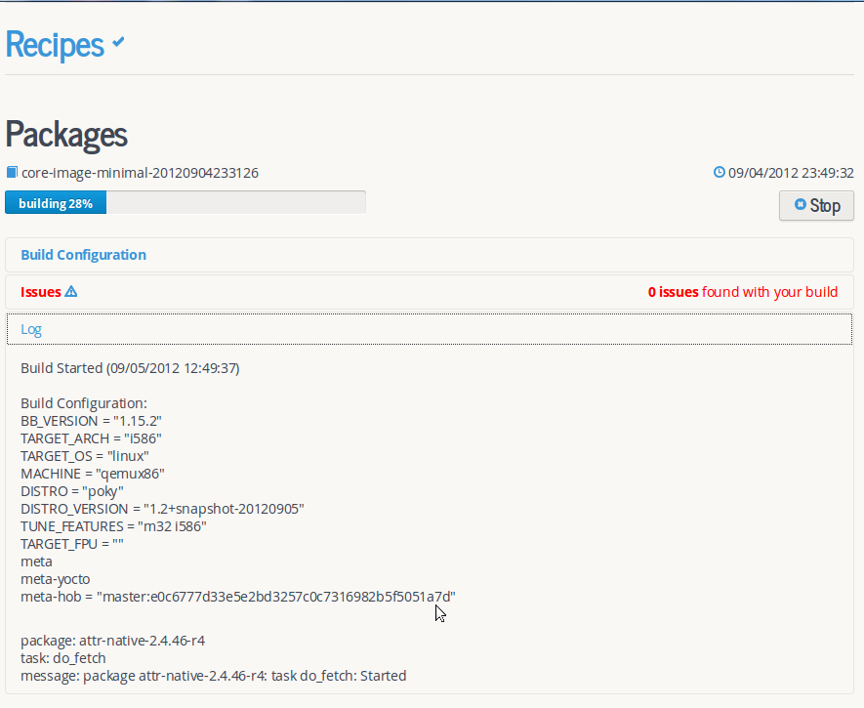
picture 19
click , display the progress of current build.
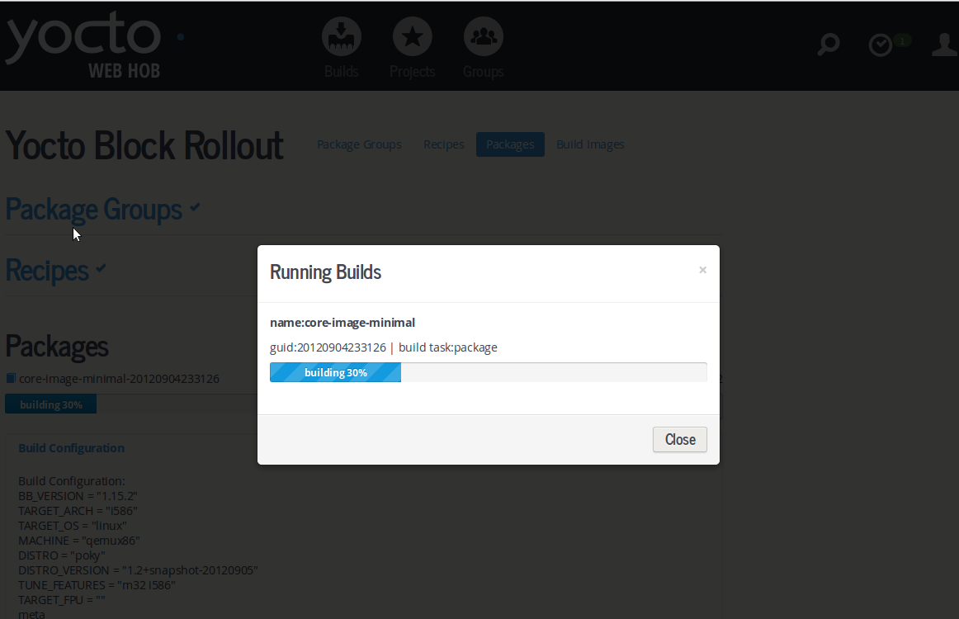
picture 20
- build image
click  or , start to build image.( picture 21)
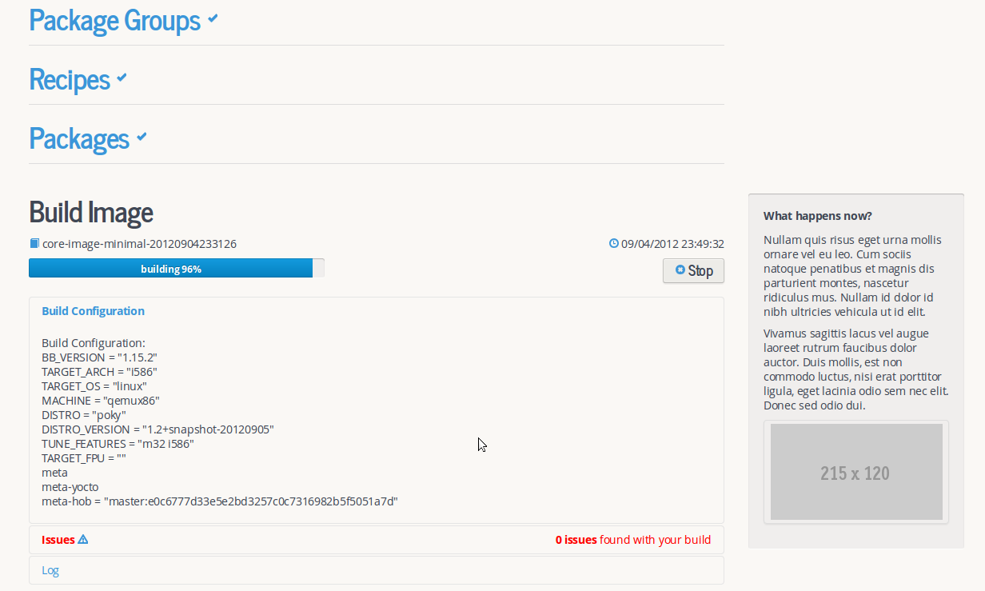
picture 21
when build image successfully, then display image file list.( picture 22)
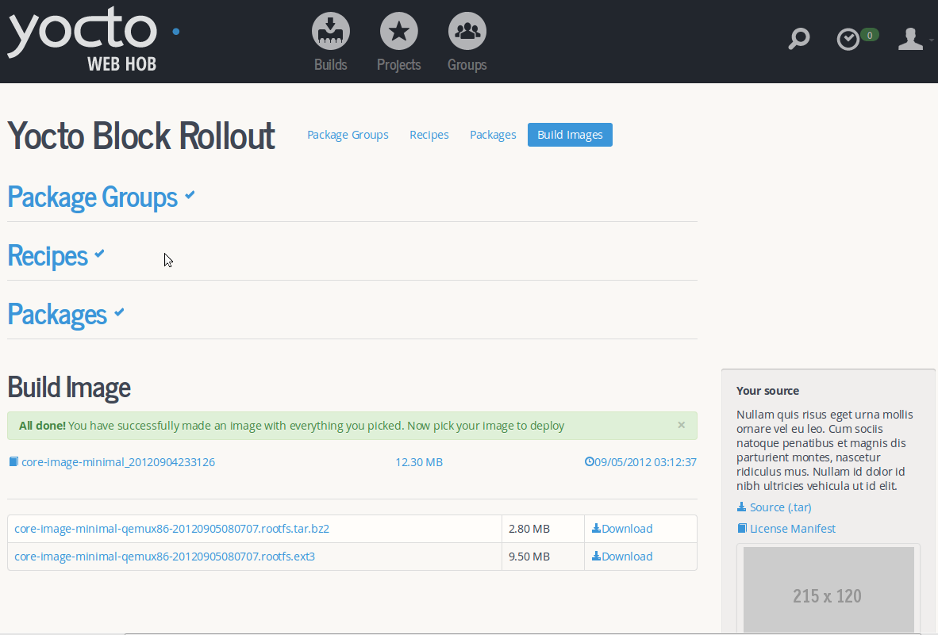
picture 23
- fast build image
fast build image contains build package and build image. when build package is complete, the system will go on to build image, once build image is ok, generating images list. user can download image file by clicking “Download”.

Builds
click , you can see all success build records.( picture 24)
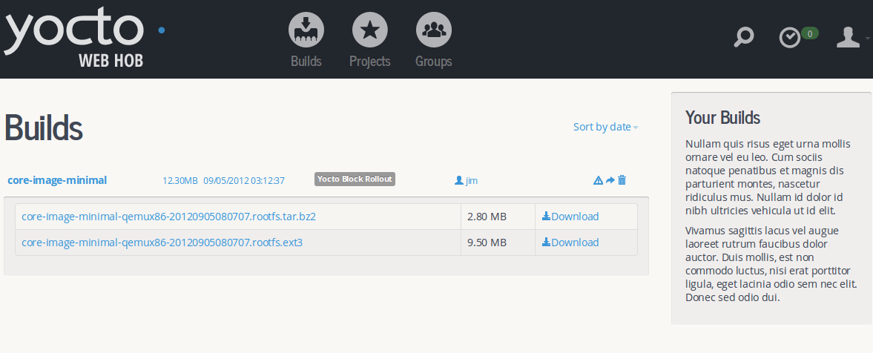
picture 24

Groups
click , to see user’s groups info, user can add new member to group(*note: prohibit to add the same group to webhob).( picture 25)
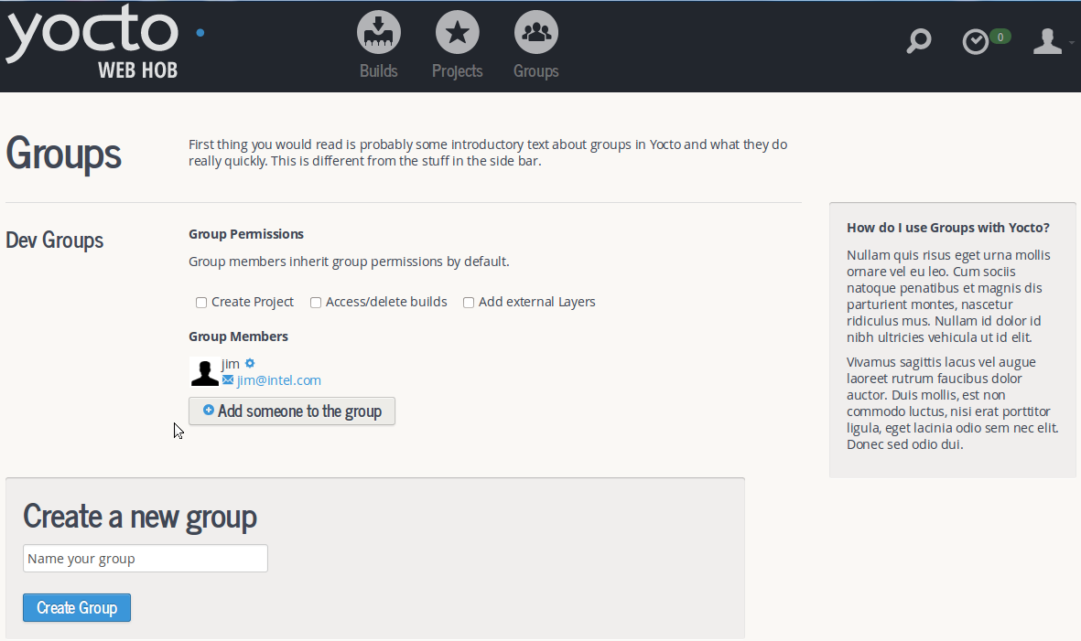
picture 25

Administrator
- admin login
webhob mainly contains two function modules, including administrator management and user management (namely webhob), administrator is mainly responsible for adding bitbake server and removing bitbake server, reset bitbake’s status,config the operating environment for bitbake server, such as git clone url, branch, nfs root url, build url and so on, start or stop bitbake server. Visit administrator url: http://localhost:8000/admin_login/ ,username is admin, password is admin ( picture 26)
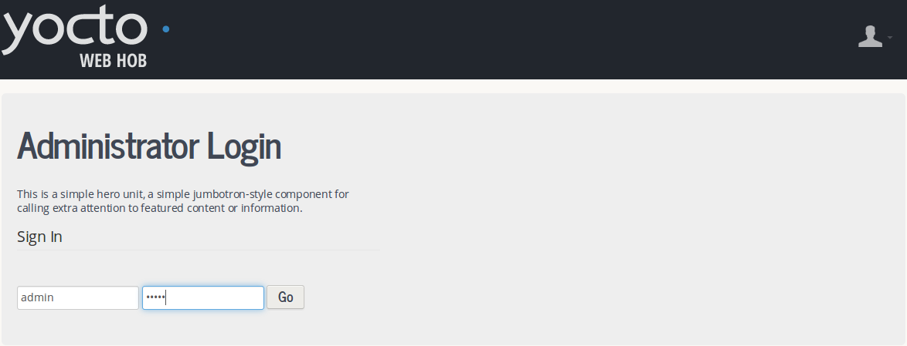
picture 26
- admin management
when username and password are correct, then go to admin management page. user can edit or delete bitbake.(picture 27)
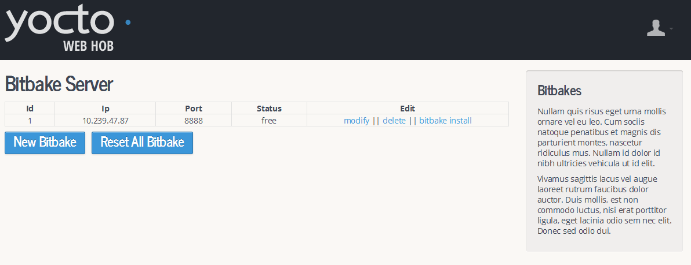
picture 27
click on “New Bitbake” button, pop-up add bitbake information window. input bibake ip and root account, click on “Connect” button , (picture 28, 29)
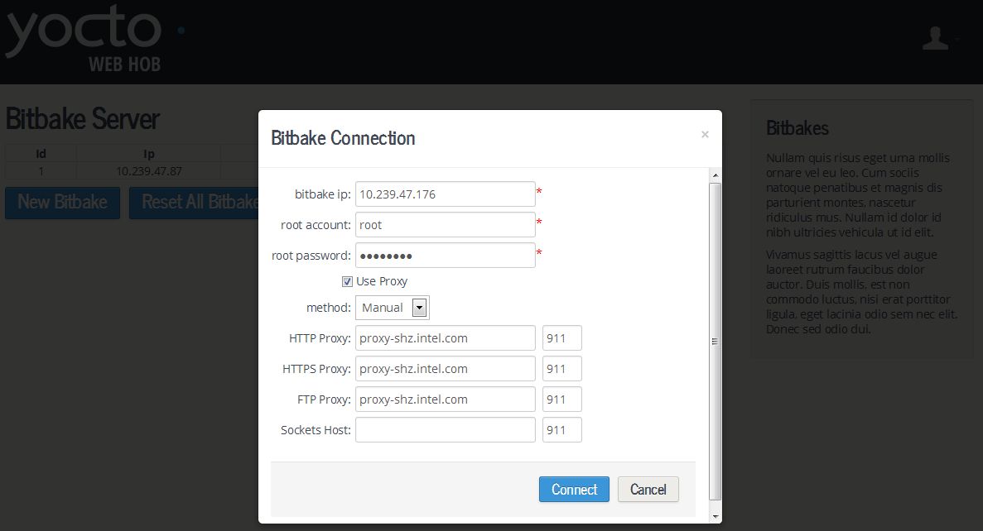
picture 28
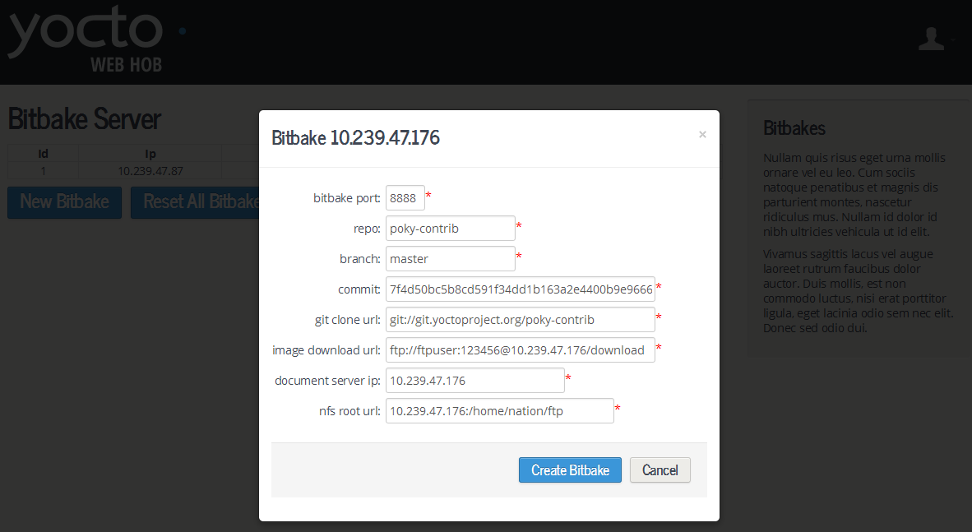
picture 29
click on “Create Bitbake” button, one bitbake server will be added to webhob successfully. click “bitbake install” and go to bitbake management page. click on “install” button to source bitbake server first, then click on “start” button to start bitbake server(picture 30)
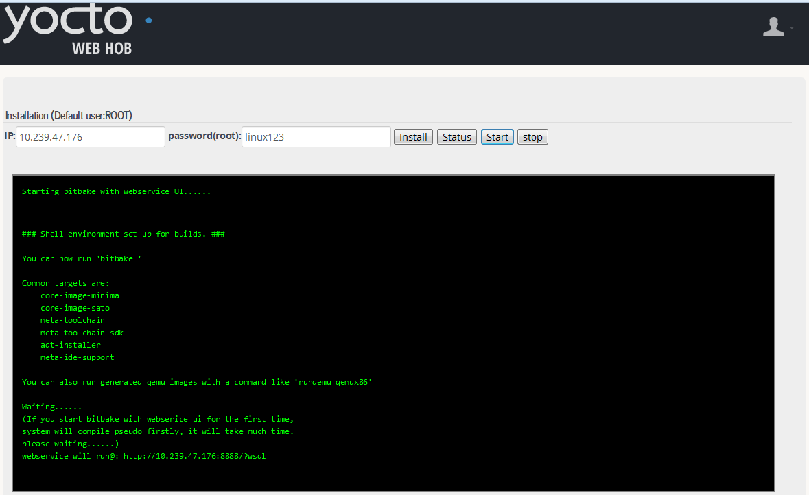
picture 30
you can view bitbake running status by clicking on “status” button.(picture 31)
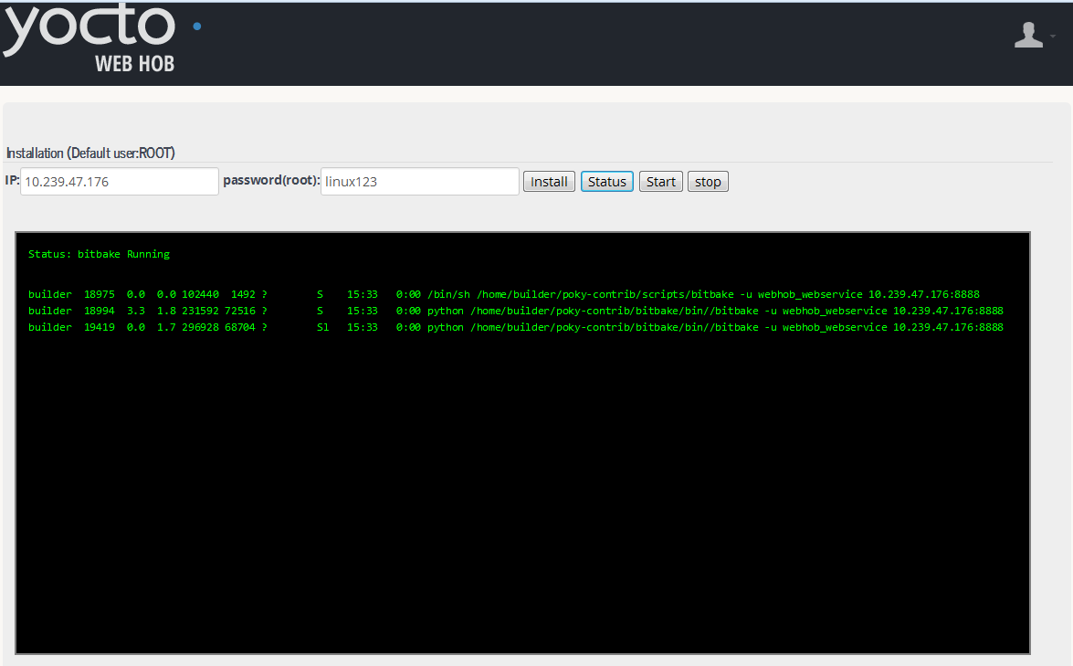
picture 31
- create webhob database steps and start django server
in ubunto system, please make sure mysql has been successfully installed, then enter the following command,
$ mysql –uroot –proot
mysql> create database db_webhob;
mysql> quit;
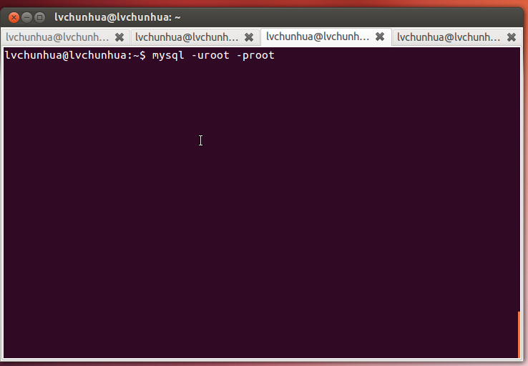
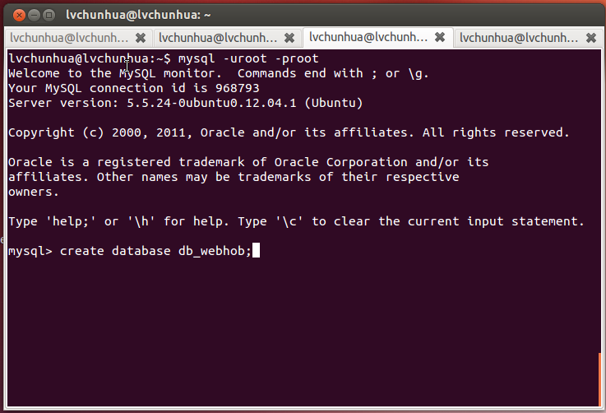
enter webHob project folder. enter the following command in the command line.
$ cd webHob/
$ python manage.py syncdb
create table …
create table auth_permission
……
create table db_package_model
You just installed Django’s auth system, which means you don’t have any superusers defined.
Would you like to create one now?(yes/no):yes
Username(Leave blank to use ‘lvchunhua’):admin
E-mail address: intel@intel.com
Password:admin
Password(again):admin
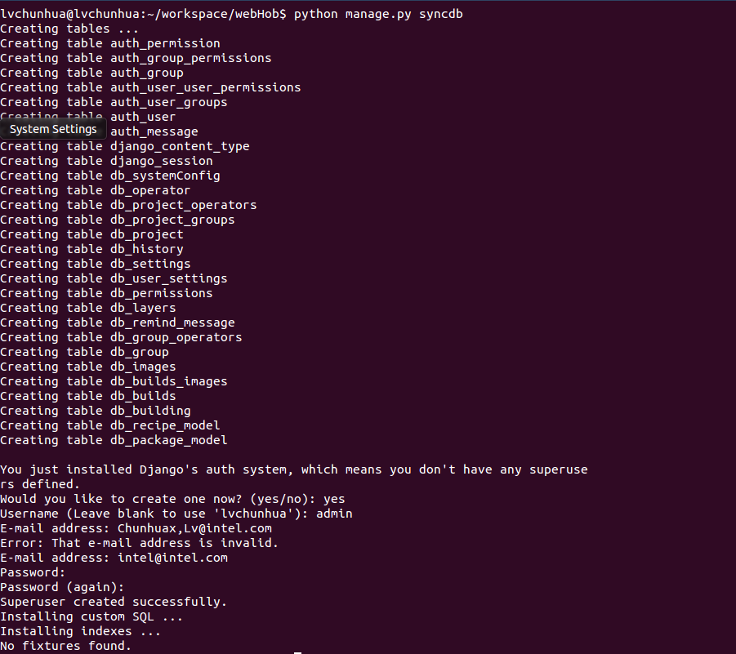
$ python manage.py runserver 10.239.47.87:8003
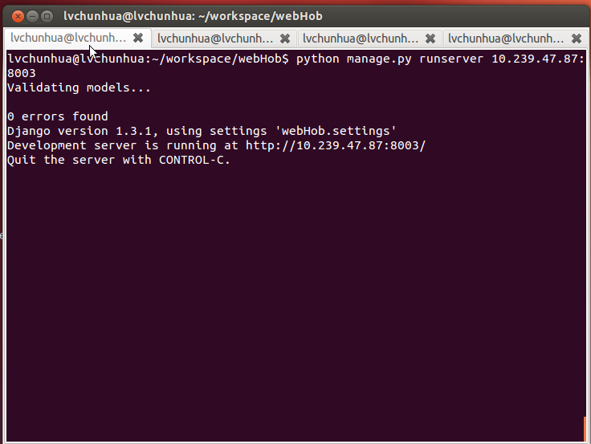
ok, django server has been launched.
- start hob management server
enter hob management folder
$ cd management/
$ python rpcserver.py
Listening: localhost, 8001
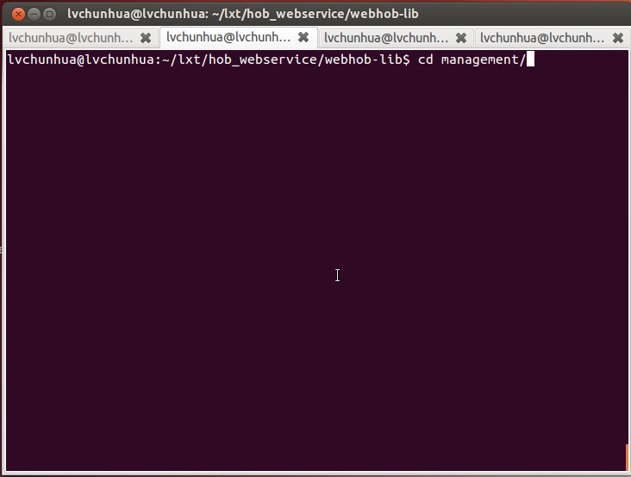
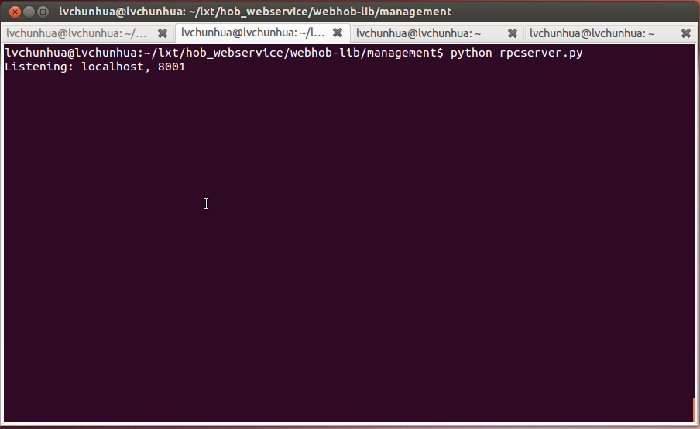
ok, hob management server has been launched. You can enter http://10.239.47.87:8003 in the browser of romote machine to visit webhob.

